SET 5 – Website Analytics Dataset
Date | Page Views | Click-through Rate
2023-01-01 | 1500 | 2.3%
2023-01-02 | 1600 | 2.7%
2023-01-03 | 1400 | 2.0%
2023-01-04 | 1650 | 2.4%
2023-01-05 | 1800 | 2.6%
Aim
To analyze website traffic and user interactions using different visualization techniques.

Q1. Line Chart – Daily Page Views
Program Name: Website Page Views Line Chart
date <- as.Date(c("2023-01-01", "2023-01-02", "2023-01-03",
"2023-01-04", "2023-01-05"))

page_views <- c(1500, 1600, 1400, 1650, 1800)

plot(date, page_views,
type = "o",
main = "Daily Website Page Views",
xlab = "Date",
ylab = "Page Views")
Observation:
Page views generally increased over the five days, reaching the highest value of 1800 on January 5.
Output:
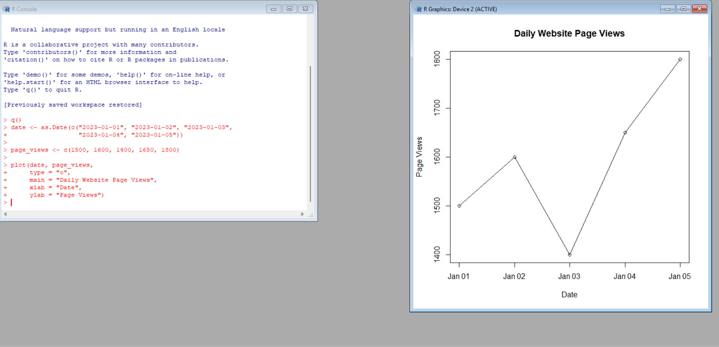

Q2. Bar Chart – Top N Days by Click-through Rate
Program Name: Top Days by Click-through Rate
date <- c("Jan 1", "Jan 2", "Jan 3", "Jan 4", "Jan 5")
ctr <- c(2.3, 2.7, 2.0, 2.4, 2.6)

barplot(ctr,
names.arg = date,
main = "Click-through Rate by Day",
xlab = "Date",
ylab = "Click-through Rate (%)")
Observation:
January 2 has the highest click-through rate of 2.7%, followed by January 5 with 2.6%.
Output:
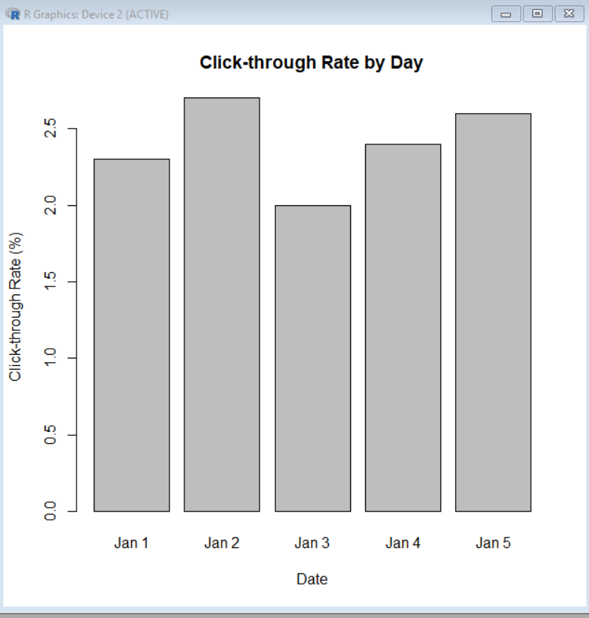

Q3. Stacked Area Chart – User Interactions
Since likes, shares, and comments are not included in the given dataset, sample interaction values are used.
Program Name: Website User Interaction Area Chart
date <- 1:5

likes <- c(100, 120, 110, 140, 160)
shares <- c(40, 50, 45, 60, 70)
comments <- c(20, 25, 22, 30, 35)

interaction <- rbind(likes, shares, comments)

plot(date, likes + shares + comments,
type = "n",
main = "Website User Interactions",
xlab = "Day",
ylab = "Interactions")

polygon(c(date, rev(date)),
c(likes, rev(rep(0, 5))),
col = "lightblue")

polygon(c(date, rev(date)),
c(likes + shares, rev(likes)),
col = "lightgreen")

polygon(c(date, rev(date)),
c(likes + shares + comments, rev(likes + shares)),
col = "lightpink")

legend("topleft",
legend = c("Likes", "Shares", "Comments"),
fill = c("lightblue", "lightgreen", "lightpink"))
Observation:
Likes represent the largest portion of user interactions, while comments represent the smallest portion.
Output:
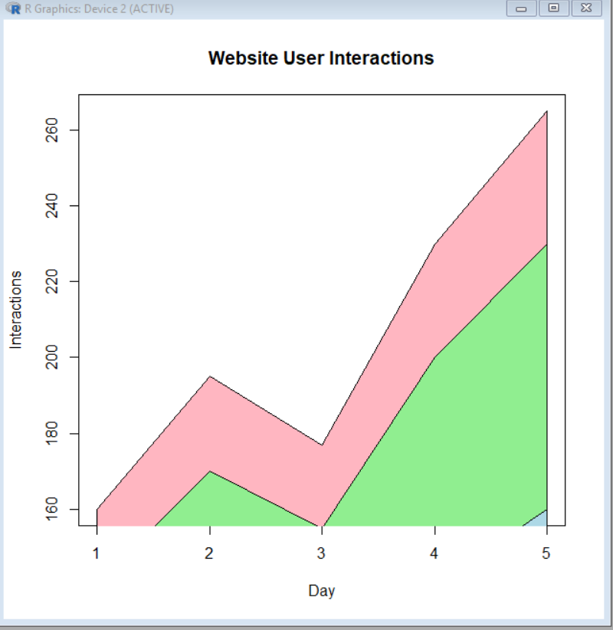

Q4. Tableau Dashboard
Program Name: Website Analytics Dashboard
Procedure:
- Open Tableau.
- Import the Website Traffic dataset.
- Create a line chart for Page Views.
- Create a bar chart for Click-through Rate.
- Create a new dashboard.
- Drag both charts into the dashboard.
- Add date filters.
- Format the dashboard.
Observation:
The dashboard provides an interactive view of website traffic and click-through rates.
Overall Procedure – Set 5
- Enter the website traffic data.
- Convert the Date column into date format.
- Create a line chart for page views.
- Create a bar chart for CTR.
- Create a stacked area chart using interaction data.
- Combine charts in Tableau.
Result
Website traffic was successfully analyzed using line, bar, and stacked area charts. A Tableau dashboard was created for interactive website analytics.

